Assignment 3 — Decision Making & Control Flow
This assignment has two parts: a short multiple-choice check on Lesson 3 concepts, and two small coding problems that put if / else if / else and Boolean logic to work.
Part 1: Multiple Choice ( __ / 8 points)

Check the box next to the best answer for each question. Each question is worth 5 points.
1. In a flowchart, what does a diamond symbol represent? (5 pts) [DAY 1]
C) A decision point
2. Which of the following correctly checks whether x equals 10 (rather than assigning it)? (5 pts) [DAY 2]
B) if (x == 10)
3. What does the && (AND) operator require in order to evaluate to true? (5 pts) [DAY 1]
B) Both sides must be true

4. Given int x = 45;, what does this code print? (5 pts) [DAY 2]
if (x >= 60) { cout << "Pass"; } else { cout << "Fail"; }

B) Fail cause 45<60 so it will print “Fail”
5. In an else-if chain, C++ checks the conditions: (5 pts) [DAY 2]
C) Top to bottom, stopping at the first true one
6. Which value is treated as false in C++? (5 pts) [DAY 1]
B) Only the number 0
7. What is the value of (7 > 3) || (2 == 5)? (5 pts) [DAY 1]
A) true
8. What happens if you accidentally write if (grade = 60) instead of if (grade == 60)? (5 pts) [DAY 2]
B) It assigns 60 to grade and the condition always evaluates as true

Part 2: Coding Problems ( __ / 22 points)

Since we won't be meeting Monday, these three problems cover the hands-on practice you would have gotten in that session — Boolean logic, relational operators, and if/else-if chains, each from a slightly different angle. Each problem is worth 20 points.
Problem 1: Temperature Classifier ( __ / 15 pts) [DAY 2]
( __ / 5 points) Draw the flow chart
START
|
Enter temperature
|
Is temp < 32?
/ \
Yes No
| |
"Freezing" Is temp <= 59?
/ \
Yes No
| |
"Cold" Is temp <= 75?
/ \
Yes No
| |
"Mild" "Hot"
\ /
END
( __ / 10 points) Write a C++ program called temp_check.cpp that classifies a Fahrenheit temperature.
☐ Ask the user to enter a temperature (as an integer) using cin.
☐ Use an if / else if / else chain to classify it using these rules:
Below 32 → “Freezing” 32–59 → “Cold” 60–75 → “Mild” 76 and above → “Hot”
☐ Print the classification clearly, e.g. “That's Mild.”
Example interaction:
Enter the temperature (F): 70
That's Mild.

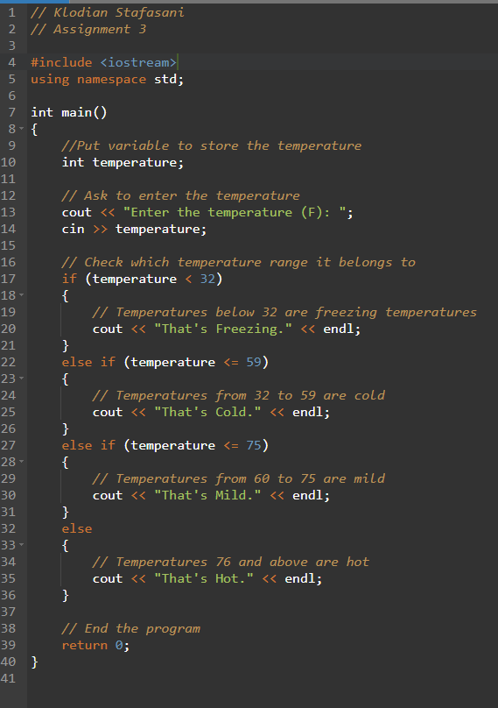

Problem 2: Discount Eligibility (__ / 7 pts) [DAY 1 & 2]
Write a C++ program called eligibility.cpp that checks whether someone qualifies for a discount.
☐ Ask the user for their age (an integer).
☐ Ask whether they're a member, entered as 1 for yes or 0 for no.
☐ A person qualifies if their age is 60 or older, OR if they're 18+ AND a member.
☐ This means combining && and || in one condition — use parentheses to make your intent clear, e.g. (age >= 18 && isMember == 1).
☐ Print whether they qualify or not, clearly.
Example interaction:
Enter your age: 20
Are you a member? (1 = yes, 0 = no): 1
You qualify for the discount.
